Emergency Contact Numbers

NO | NAME | CONTACT NO
1 | BOMBA  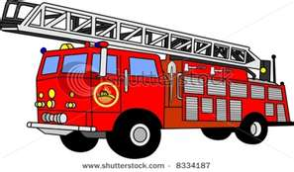 | 03 - 3342 4444
2 | POLICE   | 03 - 3392 5144  (Meru)  03 - 3250 8222  (Kapar)
3 | AMBULANCE  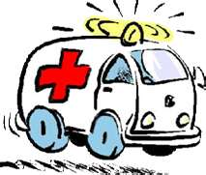 | 03 - 3372 3333  (Gen. Hospital)  03 – 3371 5005  (St. John Ambulance)
4 | FIRST AIDER – Mr. NAVIN | 016 - 469 5361
5 | SECURITY AND SAFETY DEPARTMENT
6 | GENERAL EMERGENCY NO.    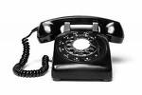 | 999  (Telephone)  112  (Mobile)

IMPORTANT
Prepared by: Ms. Chelvee Verified by: Ms.Gurmeet Approved by: Mr.Bhupindar
HR & Training Officer Snr. HR, Admin. & Senior HR Manager
Training Executive
Date: 03/06/2011
During an emergency, first call the nearest Bomba, Police and/or Ambulance. By calling 999/112 may cause delay in life saving and further property damage.

